August 4, 2002

The following information is made available for public use on a No Charge basis. Copyright for this document is held by Gilbert M. Hale, of New Freedom Data Resources. All rights are reserved. It is asked that no alteration be made to the body of this document, and that all edits to the information herein be added as addendums, along with information referencing the dates and authors who made adjustments. Also, please eMail me any changes so I can post the altered document(s) on my FTP server (gil@gilhale.com).

Credit for my having been directed to the TextPad4 application is given to John Schultz, a well-known Aspect programmer who has his roots in the early Datastorm days of ProComm’s development (http://www.aspectscripting.com/index.html).

John Schultz also “became” a Contributing Editor for this document. He provided insight for several capabilities of TextPad4 that I had overlooked. John also proofread the document and reviewed the Aspect2002.syn file I have listed on my ftp Server. So, in short, any errors are his <g> for not catching my oversights <double-g>. Seriously, many thanks to John for his efforts. What started as a little 5 page document to share some findings with him turned out to be well over 25 pages. The poor guy got roped into the midst of the firestorm as it raged out of control with new discoveries popping out from both of us. The least I could do was give him some much deserved recognition for his time and trouble.

Okay, let’s get the business end of this document out of the way. TextPad is a registered trademark of the Helios Software Solutions organization, and TextPad4 is a product designed and owned by them. Their web location is http://www.textpad.com/. Users may download a fully functional evaluation version of TextPad4. Fair is Fair, and I encourage anyone utilizing the TextPad4 application to properly license it once he/she has had an opportunity to evaluate it and determines it to be a useful tool for their purposes. It is within the context of helping our fellow Aspect programmers set up this wonderful Editor application, hence giving TextPad4 a fair shot at becoming hyper-useful within the Aspect environment, that this document was created. Okay, it was also created so I could show off a little bit, and make another contribution to my fellow ProComm/Aspect developers.

Now, on with the show!

There are several changes you can make with TextPad4 that will help kick it into high gear as an excellent Aspect Editor. The following recommendations will give the Aspect programmer a really strong leg up on moving to a really slick application to cut Aspect code, and to even fire off .wax compilations from within TextPad4.

While going through this document feel free to cut, weld, & splice as you see fit. Every user has his/her personal preferences. In fact, that is what makes TextPad4 such a potent tool. I found it is highly configurable for the Aspect programmer.

Assuming you have already installed the TextPad4 application, let’s start with the Syntax highlighting setups. Before you can properly use TextPad4 for this feature you must first download the “Aspect2002.Final.Syn” or some other “Aspect.Syn” file and place that file into the “TextPad4\System” directory. As of August 4, 2002, you can find my version of the Aspect2002.Syn file at the following ftp Server site (connect as an anonymous user, then navigate to the TextPad directory):

ftp://gilhale.d2g.com

If you have a hard time connecting let me know via eMail. Sometimes my firewall gets a little picky <g>.

You are able to modify the Aspect2002.Final.Syn file to your own liking. I am not going to cover the details on how to modify that file, as once a programmer gets inside the guts of the file it is pretty evident what is going on in there. I would recommend you rename the .Syn file you have modified, however, just in case there is an “opportunity for correction” (okay, an “error”), or if you want to publish your version for others to use.

Next you need to create a new Document Class, as shown below.

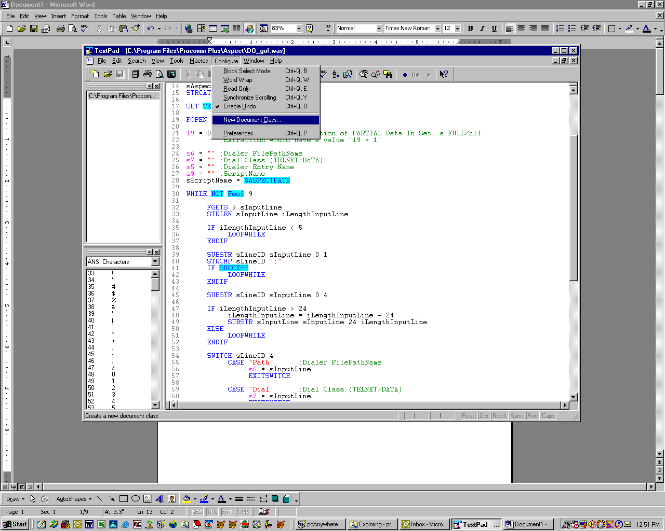

Select the Configure|New Document Class menu option.

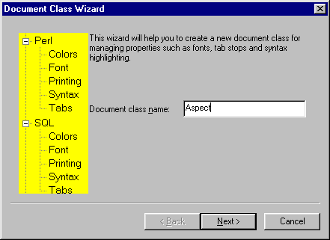

Key in the Document Class name as “Aspect”, then LeftClick the Next button.

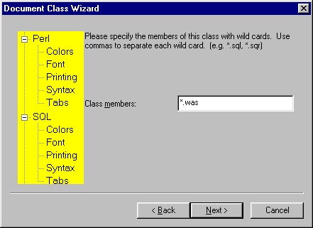

Key in the “*.was” file extension value, then LeftClick the Next button.

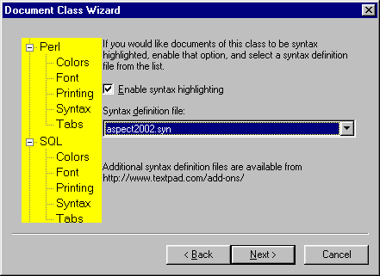

LeftClick the “Enable syntax highlighting checkbox to place a CheckMark in it. Then select the Aspect2002.syn (or an alternate selection) file from the DropDown box. Then LeftClick the Next button, then after reviewing the changes LeftClick the final form’s Finish button.

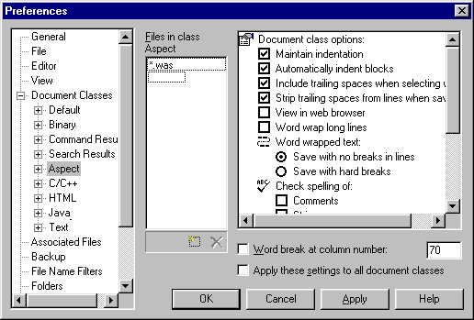

LeftClick the “+” sign on the object tree in the left panel for Document Classes, then highlight the newly created Aspect option. Make certain the “.was” extension value is entered into the center panel. If it is missing you can add it using the object indicating a new file in class Aspect form. In the right panel select the options that appeal to you.

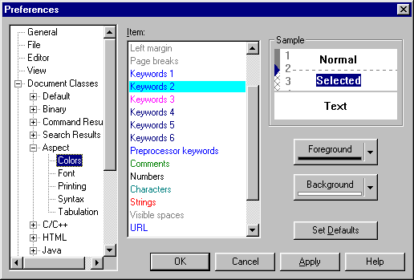

After making the initial selections expand the Aspect tree and highlight the Colors option. Alter the values shown to your heart’s content. I am showing the values I selected, some of which are the default values, others are values that appeal to me and/or are similar to other syntax coloration schemes I use for other application editors (such as Visual FoxPro v-7.0).

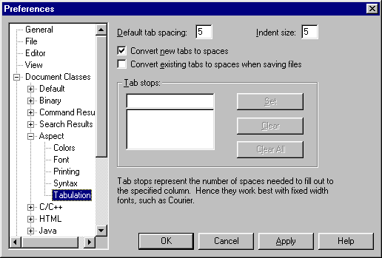

Highlight the remaining Aspect configuration elements to alter those settings as you wish as well. One area I suggest altering is to change the New Tabs to spaces, and I like using a 5 space value.

Before going any further I suggest setting up your Aspect Compiler options, if you have not previously done so, within the ProComm Aspect Editor. Begin by opening the ProComm Aspect Editor application, then open a New File (which displays a more complete menu than with no document open at all). Select the Tools|Compiler Options menu, which results in the screen below:
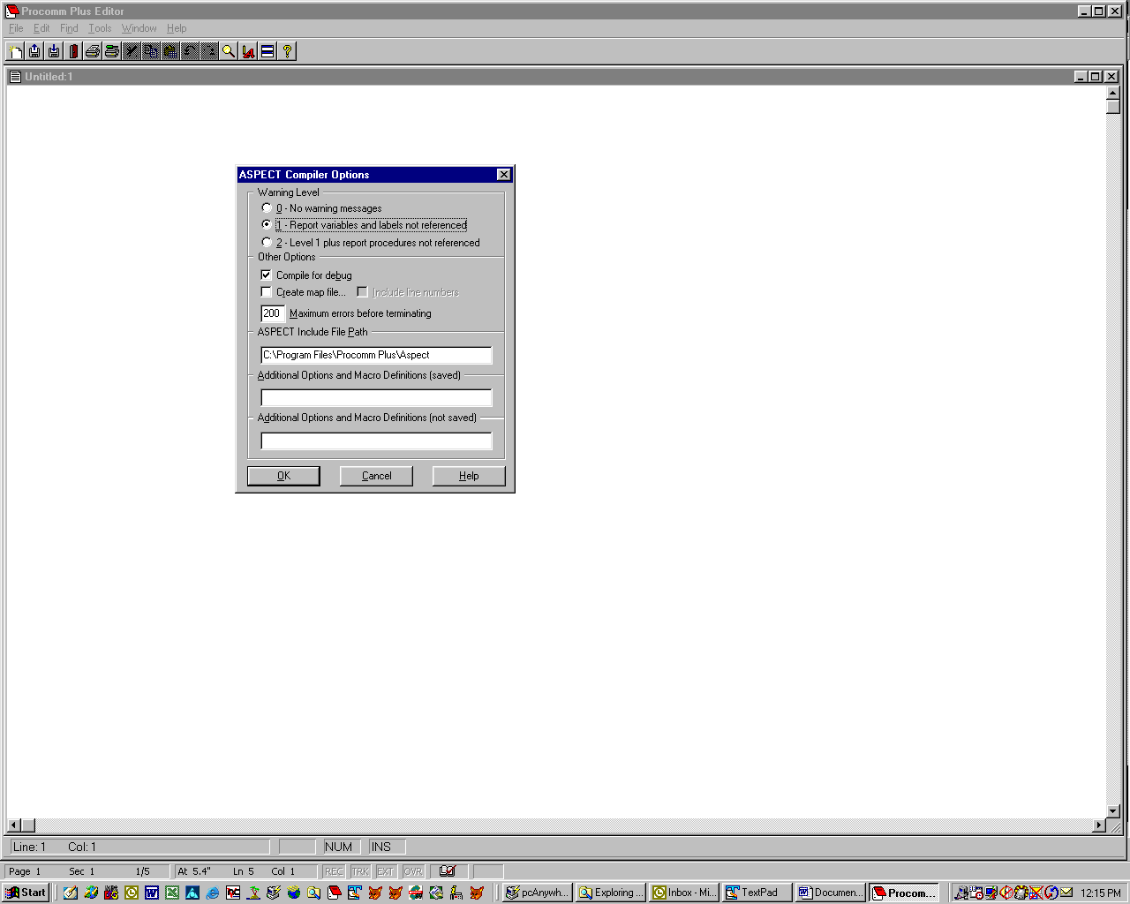

Make your compiler option choices, such as “Compile For Debug”. After making your choices LeftClick on the OK button to commit your changes into the pw5.ini file.

I am showing my personal preferences in the Screen Shot above. You can use what you like.

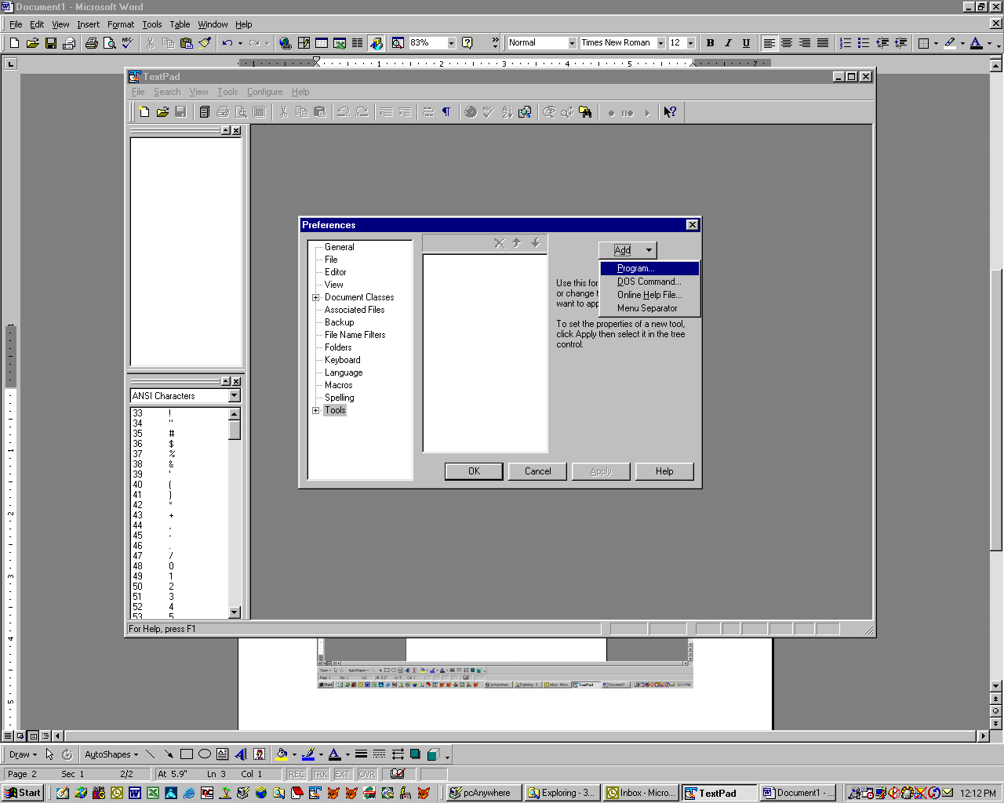

Within the TextPad4 application, select the Configure|Preferences option. Highlight the Tools object in the left panel. LeftClick the Add button in the UpperRight part of the form, then select the Programs option.

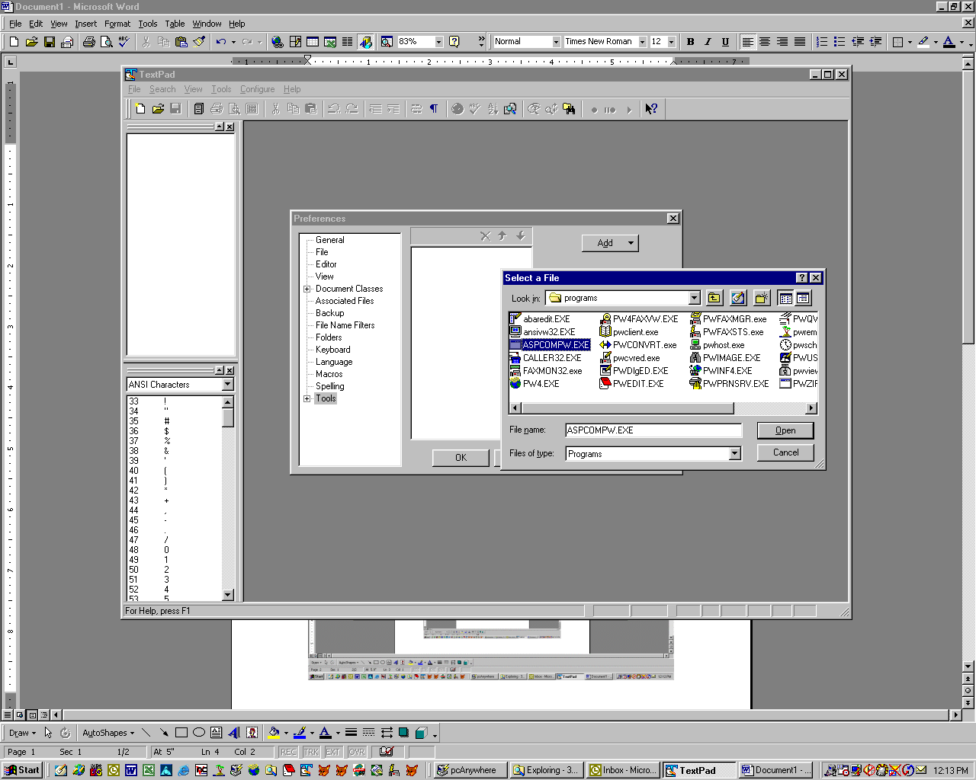

Navigate to the location of the ProComm file named “ASPCOMPW.EXE”. The location of this file will depend on the ProComm version and Operating System version you are using. But in all cases it will be in the “Procomm Plus\Programs”, which may be under “\Program Files\” or “\Program Files\Symantec\”, unless the installation placed the ProComm application into a non-default directory.

After locating and highlighting the ASPCOMPW.EXE file, LeftClick the Open button.

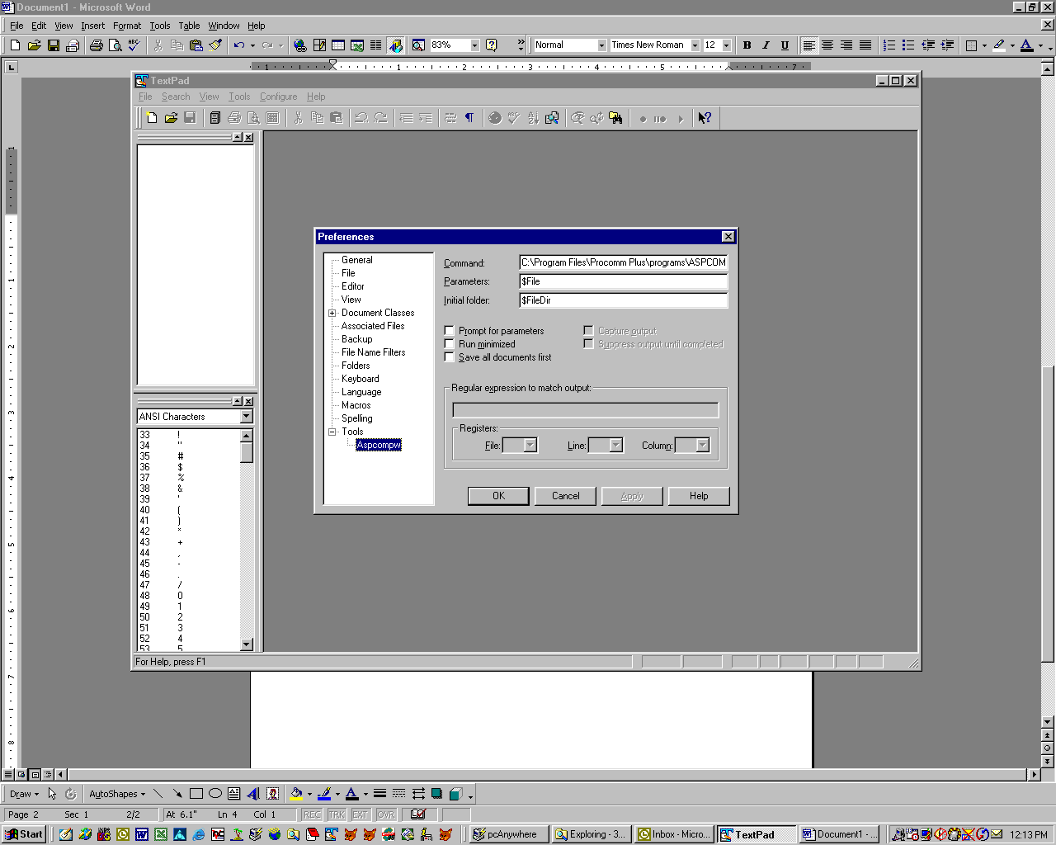

Expand the Tools tree in the left panel and highlight the “Aspcompw” object. If the values look correct LeftClick the OK button.

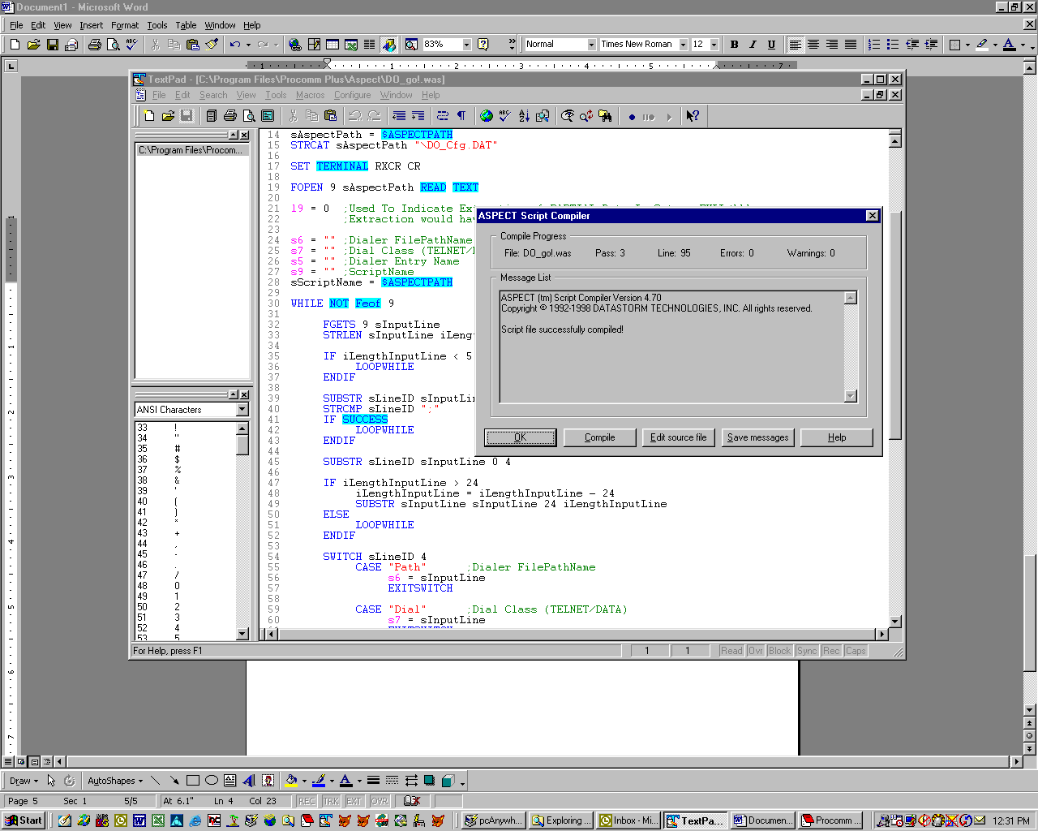

To call the Aspect Compiler from within the TextPad4 application, merely select the Tools|Aspcompw option. When the compilation is complete you will see the familiar Aspect Compiler screen. If there are errors or warnings detected during the Compile process you will get a listing of those errors, just as you would have seen had you executed the Aspcompw.Exe application from within Aspect.

As an aside, with no further changes to the TextPad4 application setup if you select the option to “Edit Source File” the Aspect editor will open the .Was file you are working on. I figured there was a way to alter the default editor to use TextPad4 within the ProComm or Aspect setups, but I had not bothered to research that. But, John Schultz did research it, and following are his comments:

“..… is how to configure Procomm to use TextPad as its default editor. If you select the Options | System Options | System Options menu item in Procomm, you can change the value of the Editor name and path edit field to point to the TextPad executable. I've made this change and it works for the case that you mention in your document. The only place this doesn't work (and which was throwing me at first!) is the Tools | Scripts | ASPECT Editor menu item in Procomm. Selecting this menu item will always launch Procomm's own ASPECT Editor.”

Following is a Screen Shot showing John’s recommended setup:

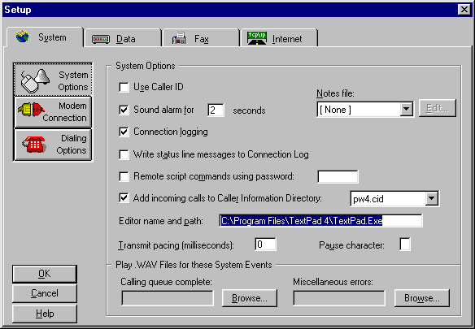

Notice that I placed the TextPad4 Directory and File Name in the “Editor path and name” field. Surprisingly I did not have to nest the value inside a set of Double-Quotes due to the nested blank space in the Path String. That is another great example of some really clean programming on the part of the designers of the ProComm application!

Another good point John made re: the Compiler Tool Setup within TextPad4 follows:

“… how to add compile-time flags to the command line. If you select Configure | Preferences, expand the Tools tree item, and select your compiler tool, you can check the Prompt for parameters checkbox and you will be able to add different flags for the compiler to use.

Here's the list you get when running aspcompw /?

Syntax: ASPCOMPW [options] filespec
Options: /Dx[=text] Define macro x [and initialize to text]
/En Set maximum allowable error count to n (default 20)
/ES Save messages to error file (with .ERR extension)
/F Generate far calls to procedures and functions
/I Include file path(s) (separate paths with
semicolon)
/M[L] Generate symbol map [with source line reference table]
/N Ignore command line options in PW5.INI file
/O Disable compiler optimizations
/Q Quiet operation mode (no screen output)
/S Compile with syntax check only
/Wn Warning level n where n = 0, 1 (default), or 2
/X Exit immediately after successful compile
/Z Compile script with run-time debugging
information

/N is a big one because it lets you override any options you might have in your INI file.”

Okay, let’s move into some other really slick changes you can make within TextPad4 to make it even more useful in everyday Aspect programming.

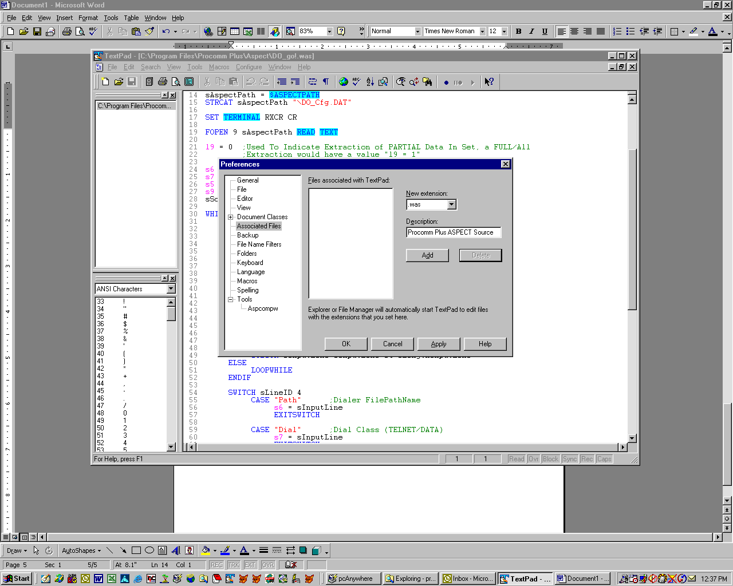

To make things a little easier when opening your .was files you can navigate to the “Preferences|Associated Files” menu and enter “.was” as a New Extension. The default description displayed correctly identifies the .was files as Aspect Source files. LeftClick on the Add button to save your changes.

But wait, there’s more!

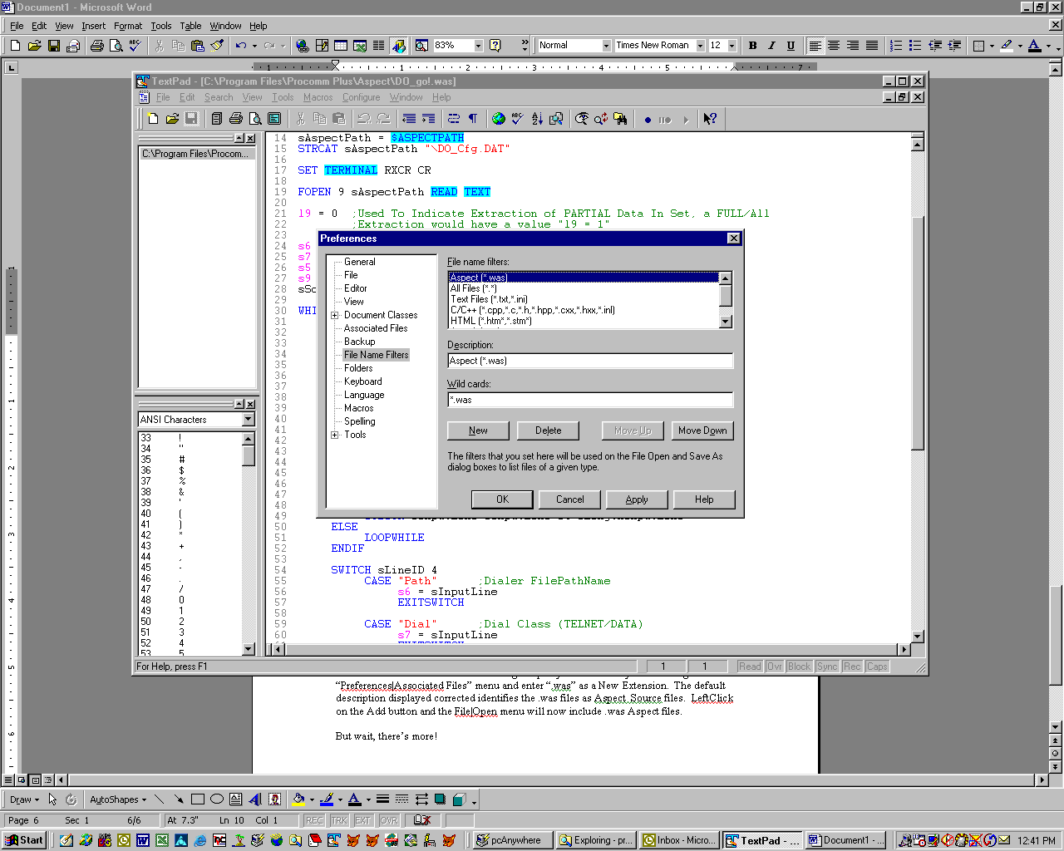

If you select the “File Name Filters” option you can include *.was files in the “File|Open” menu option Select List. Moreover, you can LeftClick on the “Move Up”
button to cause the “Aspect *.was” description to be the first choice of the File|Open type. Moreover, if you move the *.* option to the bottom of the list the .was file type becomes the default value when you select the File|Open menu option. Pretty cool, eh?

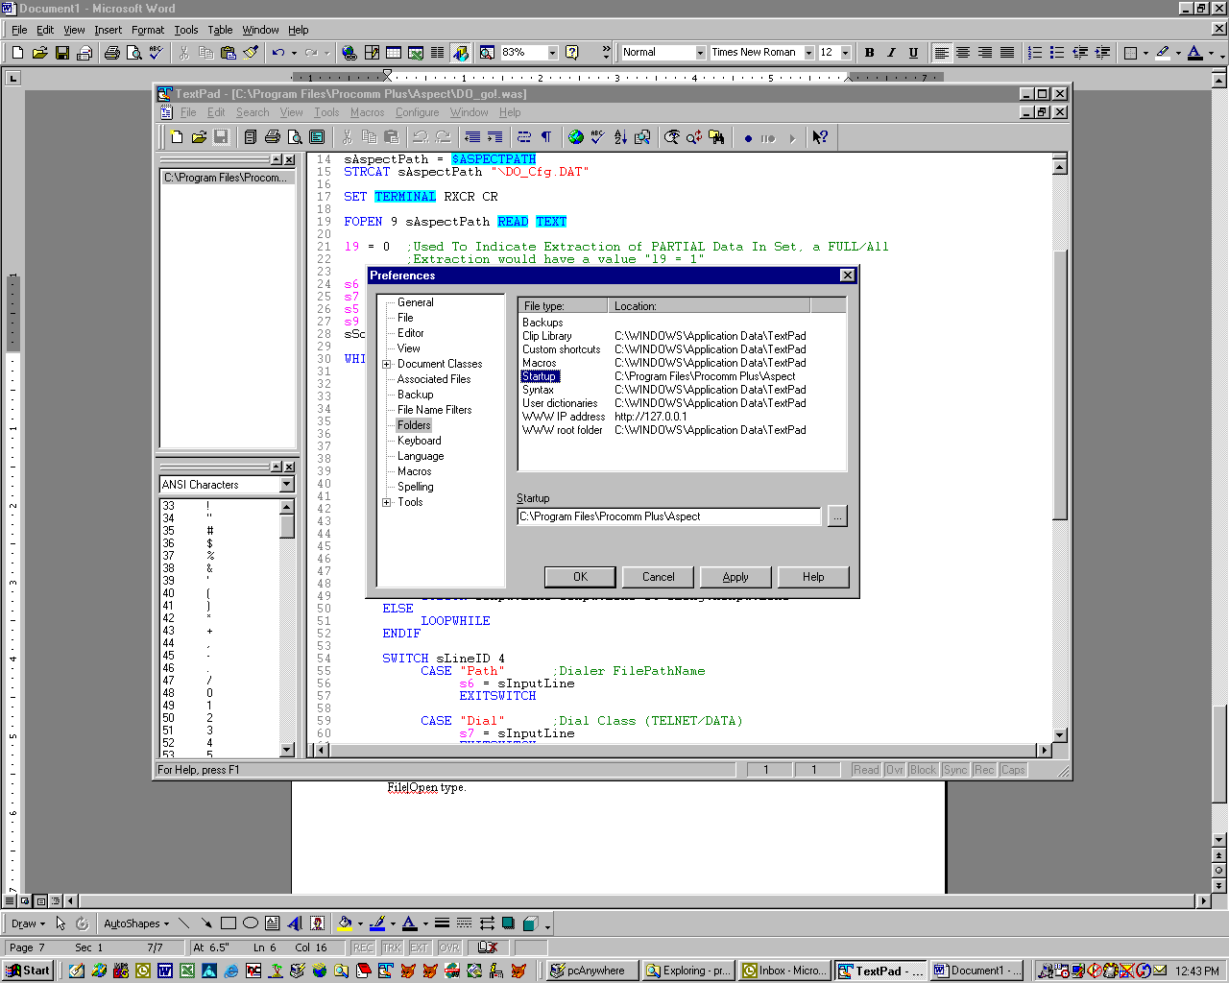

By going into the Folders selection, you can change the Startup directory to the location where your .Was Aspect Source files are located. This way you will not need to manually navigate to the .Was file directory every time you want to open a file. This also places a new file into the same directory by default.

Now for the Final Act. I really like being able to call up the Aspect Help file for the Aspect Command Reference from within the ProComm Aspect Editor. You can do the same thing with TextPad4 as well. To do so, let’s go back a few steps. The technique is similar to setting up TextPad4 to run the Aspect Compiler via the Tools menu.

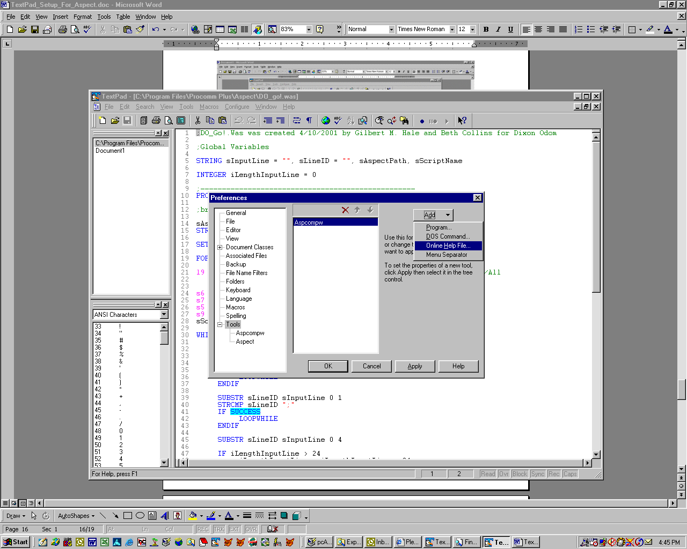

Within the TextPad4 application, select the Configure|Preferences option. Highlight the Tools object in the left panel. LeftClick the Add button in the UpperRight part of the form, then select the Online Help File option.

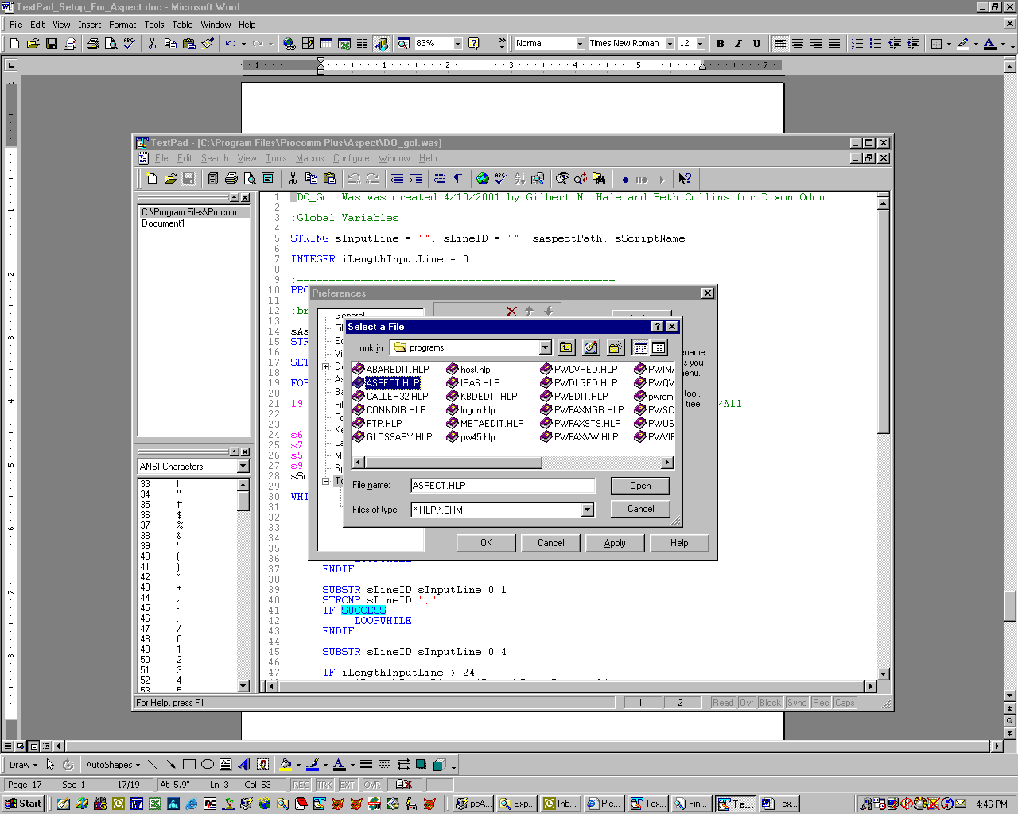

Navigate to the location of the ProComm file named “ASPECT.HLP”. As with the Aspect Compiler, the location of this file will depend on the ProComm version and Operating System version you are using. But in all cases it will be in the “Procomm Plus\Programs”, which may be under “\Program Files\” or “\Program Files\Symantec\”, unless the installation placed the ProComm application into a non-default directory.

After locating and highlighting the ASPECT.HLP file, LeftClick the Open button.

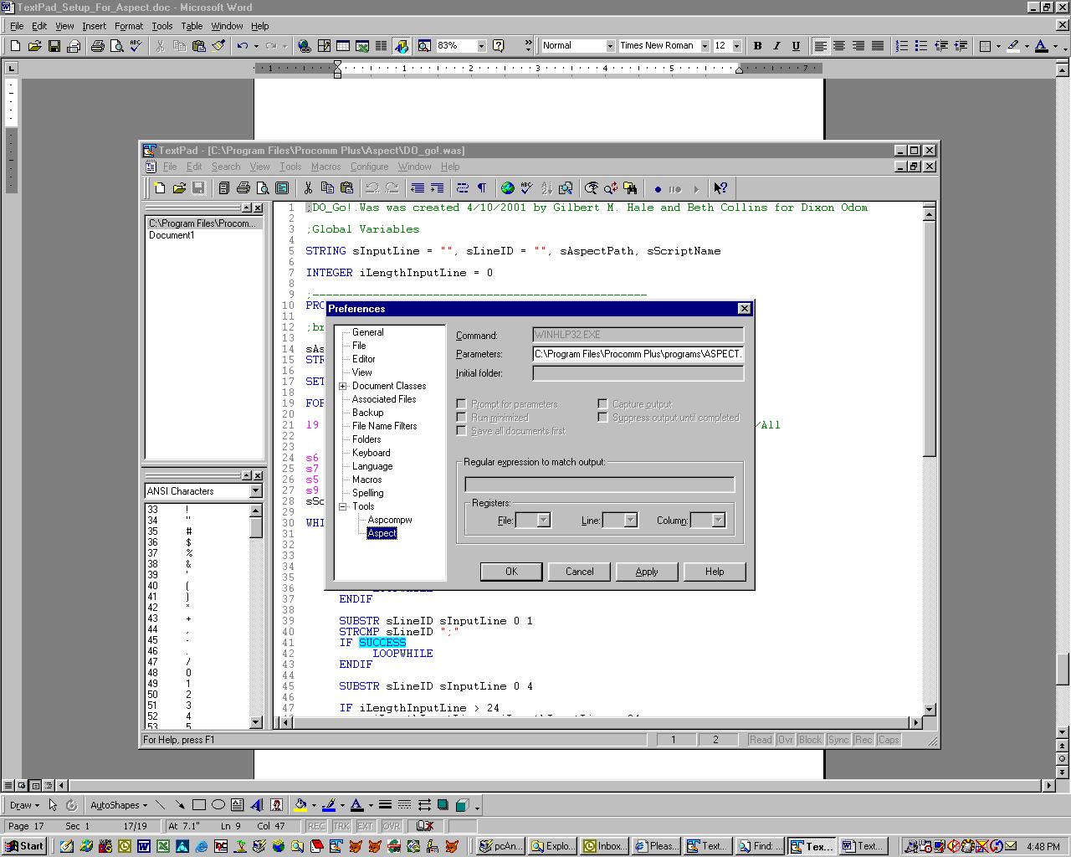

Expand the Tools tree in the left panel and highlight the “Aspect” object. If the values look correct LeftClick the OK button.

To call up Aspect Help from within the TextPad4 application, merely select the Tools|Aspect option. There’s nothing else to it. It’s that easy.

Now then, let’s make it even easier by making things a little more complex. You will notice the Aspect Help, as it is set up above, pulls up all of the Aspect Help application. Perhaps all you want is the Aspect Command Reference. Well, I found a way to do that as well. The setup is virtually the same as the previous example, except I selected the “Program” option instead of “Online Help File” when I added yet another Tools object. Be certain to select the option to look for all (*.*) files while searching for the ASPECT.HLP file. The default File Type for the Programs option is “*.exe”.

Using the instructions in the paragraph above will not work as expected, however. If you try using it “as is” you would need to do some manual selection which points to the Aspect.hlp file through a dialog interface. But, there are a few small changes that will get you the desired results. Note the screen shot below:

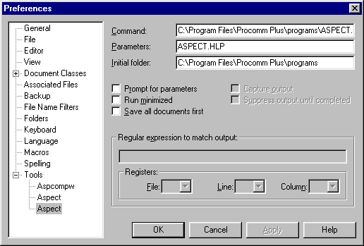

I simply added the “ASPECT.HLP” value to the Parameters field, and pointed it to the appropriate “Programs” directory for the ProComm application in the “Initial Folder” field. The result is a much cleaner form that pops up when calling for Aspect help, as shown below:
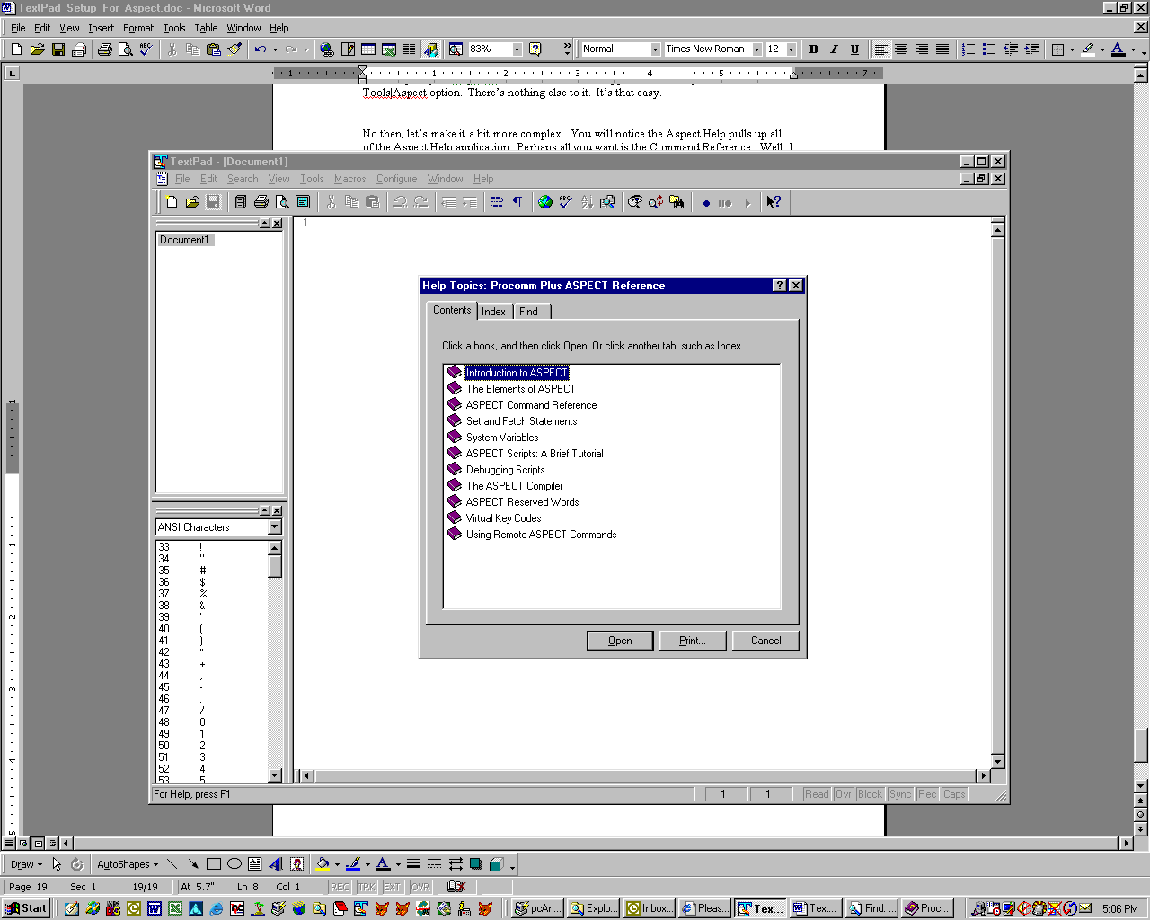

Now, for my purposes I initially deleted the first Aspect Help File Tools object, as the modified version is more to my liking. To do that you go back into the Preferences form, select the Tools object in the left pane, highlight the first “Aspect” entry, then LeftClick the “X” (delete) icon.

Later on I decided I wanted both the Full Aspect Help and the Aspect Command Help files available through the Tools menu, so I added the Full Aspect Help back. I am glad I did that, because, true to his nature, John Schultz found another little trick to share in this document. Normally I would have edited some of his text out that was not directly related to the subject at hand, but his statements are so excited I could not bring myself to chop anything out of his eMail. Put on your seat belt, here it is:

“Gil, your document on configuring TextPad for use with ASPECT files is not complete until you read this message! I downloaded the latest version of TextPad tonight (I had version 4.4.2 and did not realize that 4.5 was available). While reading the readme file, somehow the text README got highlighted. When I clicked on my tool button that opens the ASPECT help file, I noticed that it seemed to be keying off the highlighted text. Thus, I opened a .was file, highlighted a command, and clicked on the help file button. The discussion for the command was opened in the ASPECT help file! That was the last feature of the ASPECT Editor that I was trying to duplicate in TextPad and now it is possible! Good thing my wife is asleep because she wouldn't understand how cool this is.”

I am guessing John wisely let his wife remain asleep, otherwise he may not have been able to create and send that eMail to me <g>. Good decision, John! Here is what he means by his statements:

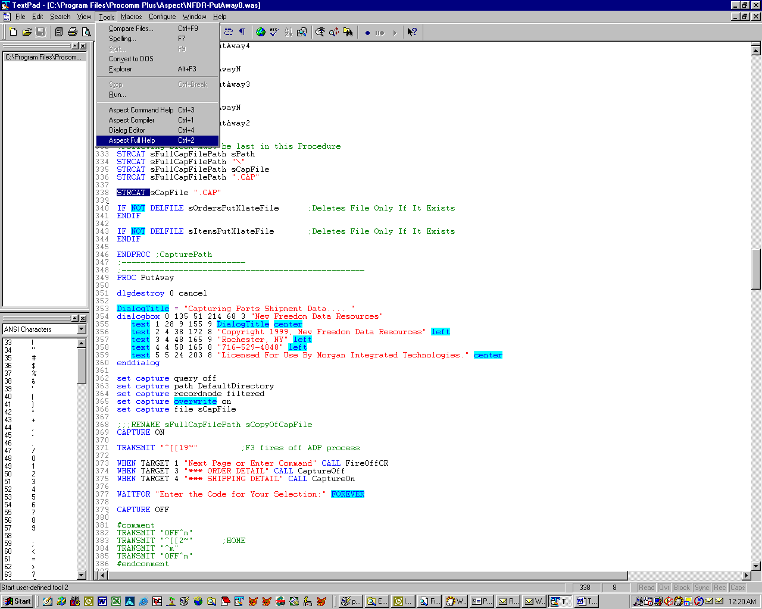

I highlighted the Command “STRCAT”, then selected the Aspect Full Help tools option. On the next page you will see what popped up.

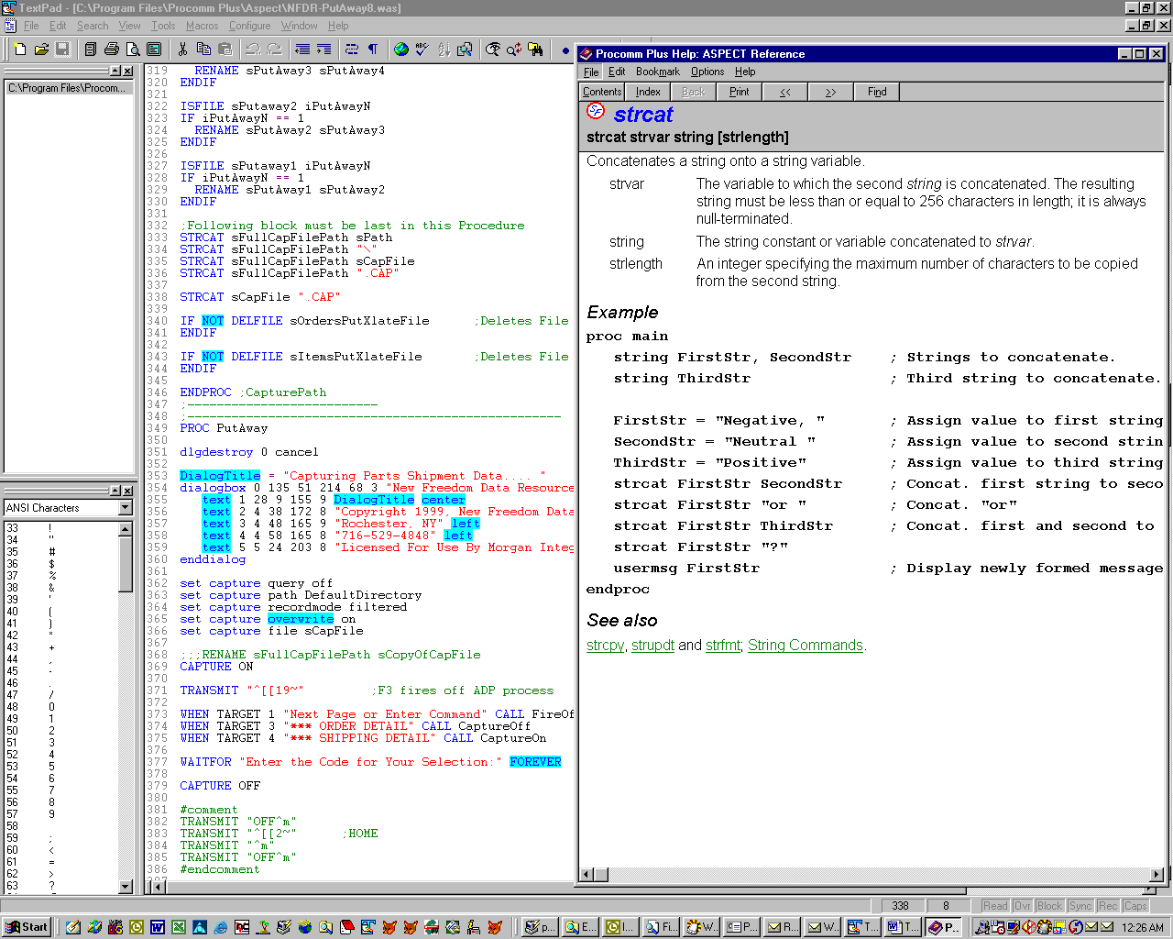

As promised, the Aspect Help application fired off along with a direct link to the Command “STRCAT” I had highlighted.

There is a little, “Oh, by the way,” that comes with this information. I mentioned previously that I was glad I am using the TextPad4 Tools menu options to fire off “both flavors” of Aspect Help. It turns out the Full Aspect Help file, retrieved via the TextPad4 “Help File” setup works as described by John. But, the Aspect Command Help does not, which is okay with me. With John’s findings one would be justified in wondering why the heck anyone would want to use the Aspect Command Help tool. Hmmm, how about “cuz we can”?

The downside to having both Help menu “flavors” available was that both Tool names were “Aspect”. I had hoped there was a way to alter the description of the Tools entries, but I had not found how to do that. Once again John came through, and he advised that the TextPad4 Help File gave instructions on how to rename a Tool. The following Screen Shot shows where you can alter the name of a Tool object.

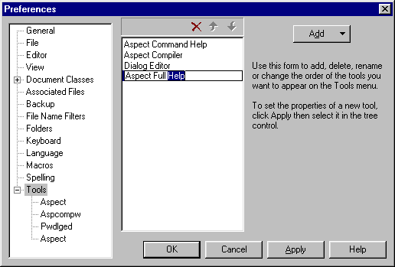

Just as John had told me, the technique used to change the Tool object name(s) comes straight from the TextPad4 Help File (RTFM, eh?). The Help File states, “If necessary, rename the tool by clicking it twice, slower than double click speed, and typing the new name. You may insert an "&" before the character you want to use as a menu mnemonic.” It works pretty nicely.

Also, you can move any of the multiple Tools objects higher or lower in their order of appearance in the Tools menu. Simply LeftClick the Up Arrow or the Down Arrow, near the top of the Tools setup form, for the Tool name highlighted in the screen above (after renaming the Tools).

Having some new options on the Tools menu to fire off some Aspect Power Tools is very nice. But wouldn’t it be much nicer to have a Toolbar Icon you could merely LeftClick to fire off the needed Aspect Power Tool, instead of having to navigate through the Tools menu? Gee, are we a spoiled crowd, or what? If you suspect you have a little treat coming, you are right. Once more, this tidbit comes from John Schultz. Here are his comments:

“….. Your new tool will be added to the Tools menu and also the Tools toolbar. If you don't want to display the entire Tools toolbar just to select your new button, it is possible to drag it to its own toolbar. To do this, select the View | Toolbars | Customize menu item, click on Commands tab, and then select Tools. Locate the button corresponding to your new tool and drag it to the toolbar area of TextPad. This will create a new toolbar, called Toolbar1, which you can rename to a more intuitive name.”

Here’s how to do it:
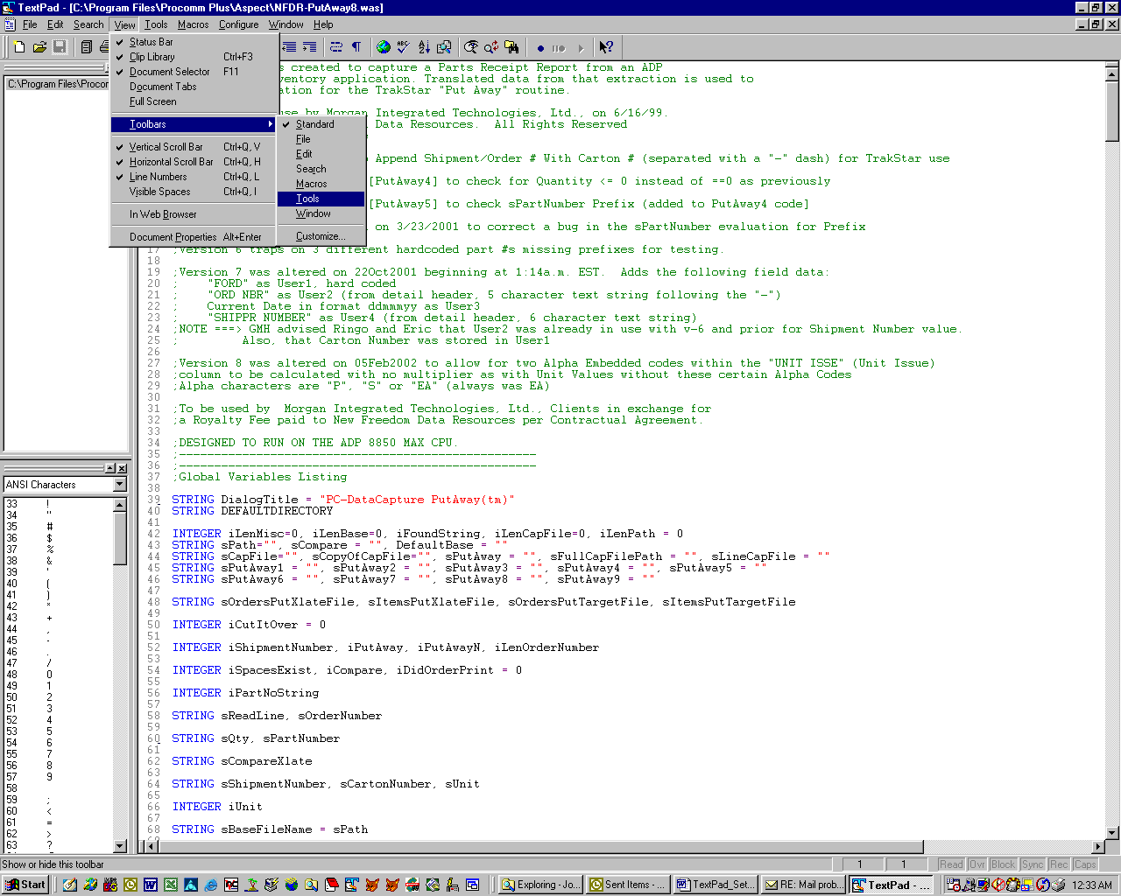

LeftClick on the View|Toolbars|Tools menu option. The TextPad4 application then displays 16 Tool icons, with the same exact appearance, other than each having a different ID Number associated with it. This is what you likely do not want to see, as it is a bit cluttered and can easily confuse an End User. So, now that you have seen how it “could have been” go back and deselect the View|Toolbars|Tools option.

Here is the better way to display your Aspect Power Tool icons. As John suggests, go into the View|Toolbars|Customize menu option. Select the Commands tab on the form. Once in the Command tab form highlight the Tools option. You will see several icons, 16 of which are little “hammer” Tool icons. As you float your mouse pointer over the Tool icons a “Tool Tip” description of the icon will appear, thus making it possible for you to determine which of the icons you want to place onto your Toolbar.

To place the Tool icon(s) onto the Toolbar simply LeftClickDrag the desired icon onto the TextPad4 Toolbar. You will notice the icon you drag onto the Toolbar is a “dockable” object, hence a little unusual looking. Fear not. Once you have dragged all of the Tool icons onto the Toolbar close the Customize|Command form. Now you can drag the Tool icons on your Toolbar “into” the Toolbar by moving them into position within the Toolbar’s upper and lower horizontal borders. If you want to drag the Tool icons off the Toolbar later on, and dock them elsewhere on the screen, you just perform a LeftClickDrag on the one you want to move.

“Hey, how can I change the Tool icon images, or rename the icon, instead of putting up with the generic Icon ID # on the Tool objects?” I actually read the documentation for this capability, and did not find a way to do that. Who knows, we may see that capability in a future version (hint-hint Helios Development Team). Personally I find it hard to gripe about that little matter, given all TextPad4 is capable of with v-4.52. So I will live with having to remember which Tool ID Number does what, and rely on the Tool Tip description to help me remember from time to time. On the other hand, if there is a way to do this, and I overlooked it, I will have to learn to live with the public ridicule that will certainly follow the publication and release of this document into “the wild.” I can think of worse fates that could befall me.

So, do you want more? This is one of those moments where I can act like a performer. Let me explain. My wife “forced” me to go to a Barry Manilow concert in July, 2002. We have also seen Elton John, Journey, Foreigner, etc., together. It seems that when the performers say “Good Night” they come back with at least one more goodie for the audience. Okay, the point? Prior to adding the Help Application section to this document I stated it was the Final Act. Nope, here is the encore…

I like using the Dialog Editor, and John Schultz recommends the same on his web site’s Tips and Tricks section. I found I can call up the Dialog Editor within TextPad4! By now I bet you can figure it out on your own, but just in case, here is how to do it:

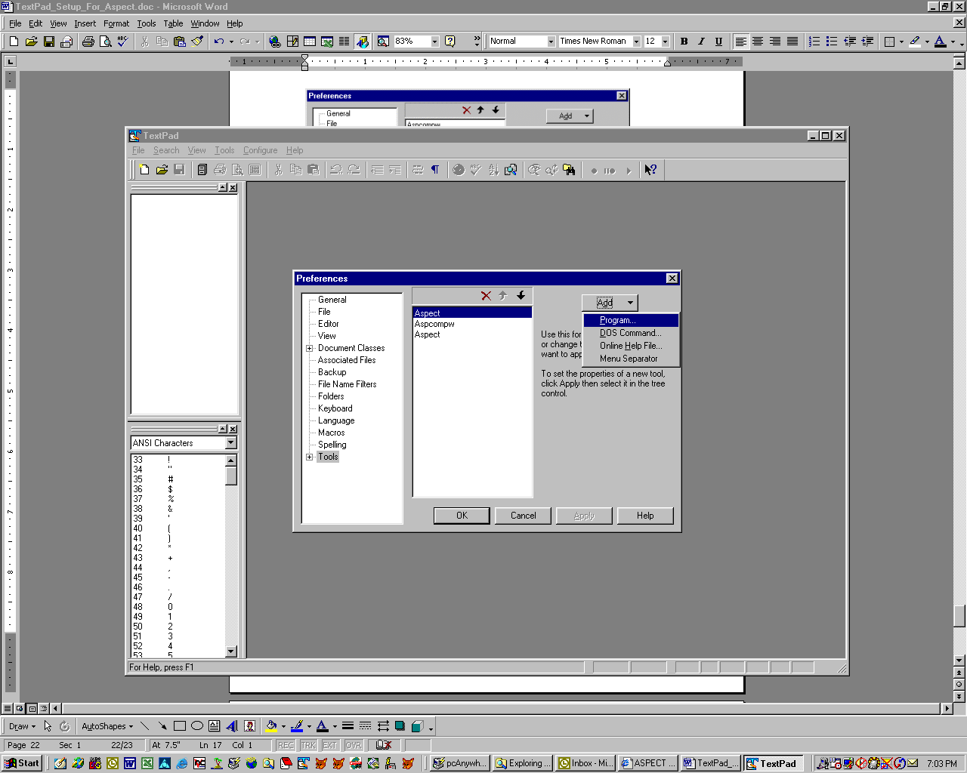

Open the Configure|Preferences|Tools section. LeftClick the Add button and select the Program option. Navigate to the “PWDlgED.EXE” file (you should know where that is by now). Complete the Tools setup as with the Compiler and Help applications and you are done.

Okay, fellow Aspect Programmers, that should get you to good starting point. I hope you find TextPad4 as useful as I have while writing Aspect code. Heck, it is nice being able to search backwards for a string value within an editor application if nothing else! Oh, let’s not overlook how great it is to see the text between #COMMENT and #ENDCOMMENT in a Comment Text highlighted color. I would hate to confess how many times I began to alter code with the ProComm Aspect Editor that I thought would change a program’s behavior, only to find later it was a large block that I had previously commented out.

Gilbert M. Hale
New Freedom Data Resources
Pittsford, NY
gil@gilhale.com

